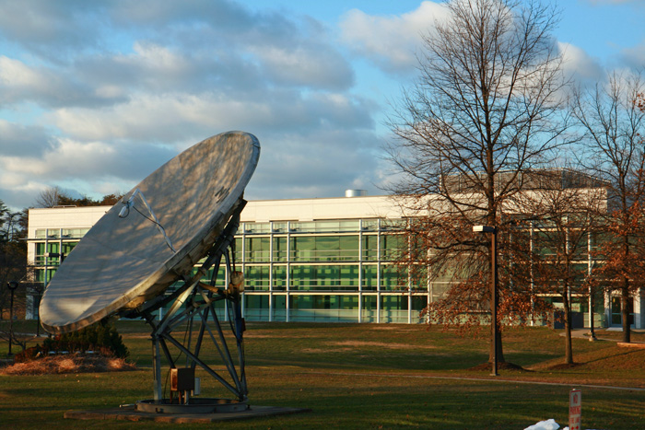

**WHAT TO EXPECT:**

* *Capitol Cyber Challenge -* The camp features a variety of exciting. informative activities, including scavenger hunts and other cyber games; training in computer forensics; coding and scripting with Python and other languages; creating software robots; and working with 3D printers. Perfect both for students who are interested in cybersecurity but don't know much about it, and also for those who have had some cybersecurity experience during high school and want to increase their knowledge base.
* *Coding Camp -* Coding is a big part of our world today. Whether you want to be a professional programmer or just want to pick up a few skills, Capitol Technology University's Python camp is right for you! Through fun, interactive, hands-on exercises using Python on a Raspberry Pi, you will learn the basics of programming using Python and how to build a functioning program on a small form-factor module like the Pi. By the end of camp, you will be able to create new Python apps.  From there, the sky is the limit!

**Cyber Summer Camps at Capitol Registration Form***Please email this completed registration form to: jlexner@captechu.edu*

**Name: School:**

**Age: Email:**

**City: State: Phone:**

**Which Cyber camp/s would you like to attend?**

Payment options:

Credit Card : _____Visa ______Discover ______MasterCard ________American Express

Credit Card # _________________________________ Expiration Date: ____________________________________

Cardholder Name ____________________________ ___ Signature _________________________________________

Card billing address (if different from student address)

_____________________________________________________________________

**Dates:**

Capitol Cyber Challenge - July 10-July 14

Coding Camp- July 31-August 4

Both camps run from 9:00a-4:00p

**Where:** Capitol Technology University, 11301 Springfield Rd. Laurel, MD 20708

**Cost:** $350 per camp

**Cyber Summer Camps**