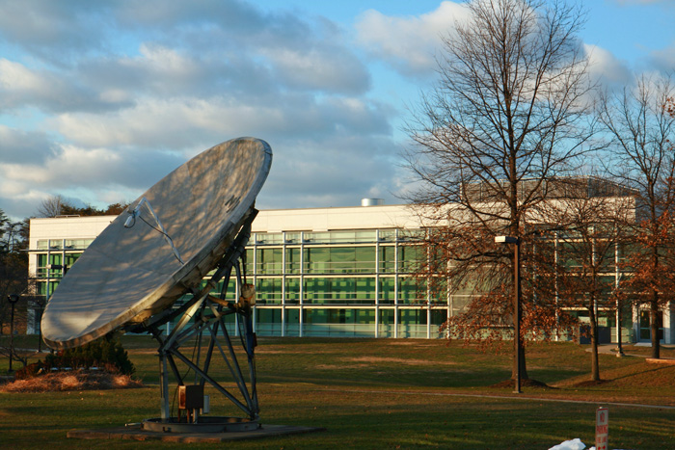

**WHAT TO EXPECT:**

* *March 15th, participants will work in teams to analyze a series of vulnerable systems in order to discover vulnerabilities according to the provided Treasure Map.  
  March 16th, will be a repeat of Cyber Laser Tag for those who didn’t get to play or would like to play again. Participants face an autonomous system that dynamically cycles exploitable services.*

**WHEN?** March 15-16th from 10:00a-4:00p

**WHERE?** Capitol College, 11301 Springfield Rd. Laurel, MD 20708

**WHY?** Capitol College would like to host a **FREE** game strictly for community college students interested in cybersecurity. This will be a weekend to learn more about cyber and play a fun game at the same time!

**Cyber Treasure Hunt**

**Cyber Laser Tag at Capitol Registration Form***Please email this completed registration form to:mayoung@capitol-college.edu*

**School:**

**Name:**

**Email:**

**City: State: Zip:**

**Phone:**

**_____________Yes I am attending the Cyber Treasure Hunt March 15th**

**______________Yes I am attending the Cyber Laser Tag March 16th**

*\*IF YOU RECEIVED THIS VIA EMAIL, PLEASE RSVP BY ATTACHING THIS FORM TO A RETURN EMAIL.\**